Title : Data Flow from Sales & Distribution to Finance.
(Domestic )

Important Information which can be seen from Sales Order

Transaction code VA03 -- The system will display “Display Sales Order – Initial Screen”. Here we should enter the sales order number.

The screen is shown below with document number of Sales Order.

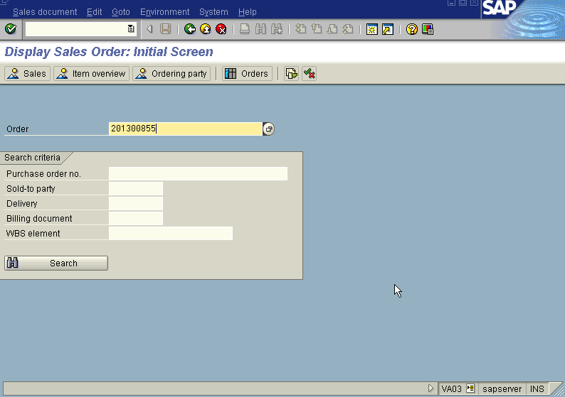

Press Enter button

The System displays “ Display Standard Order – CH 201300855 Overview” Screen indicating the details of the sales order as below viz.; Standard Order number,Net value in INR,Party number (customer number),Material number,Material quantity,payment terms etc. The screen will be displayed as under.

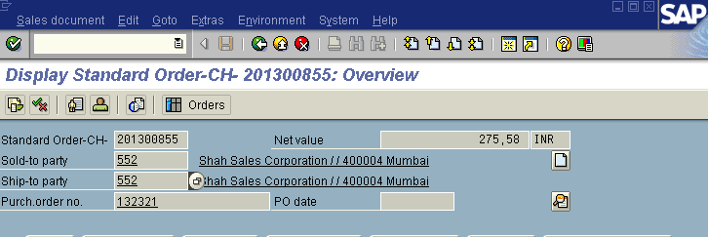
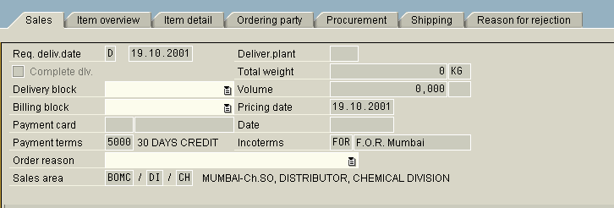
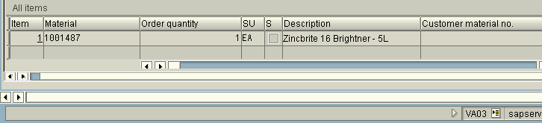

In the above screen do the following

Press Item Overview push button.
Information regarding material number, order quantity, description of the material etc are given.

In the above Display standard order screen press document flow icon (F5) we get the following screen as under

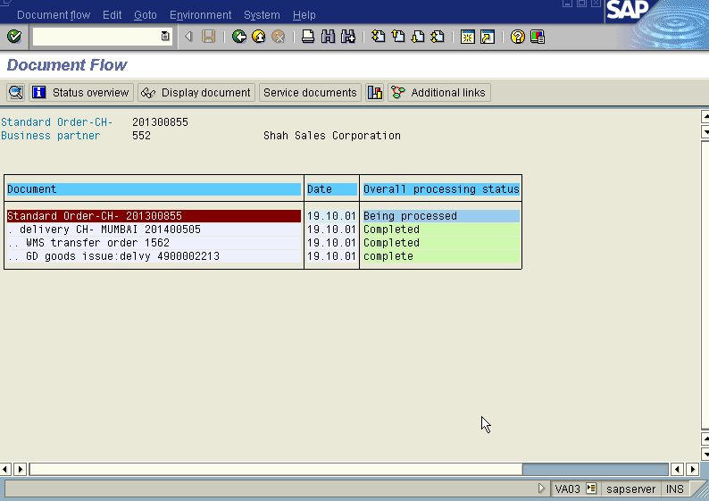

In the above Display standard order screen press sales summary (shift f7) we get all information pertaining to the customer eg: shah sales corporation viz, Address, contact person,and other details regarding order, pricing,shipping,transportation data,billing, payment and delivery terms, statistical details, credit related information etc..
In the above Display standard order screen press sold to party icon (F6) we get information regarding the following; general data,control data,marketing data-customer class,industry to which it belongs etc.

Important Information which can be seen from Delivery

Transaction code VL03N. The system displays “Display Outwardbound Delivery” screen as under in which we enter the outbound delivery number(eg. 201400505).
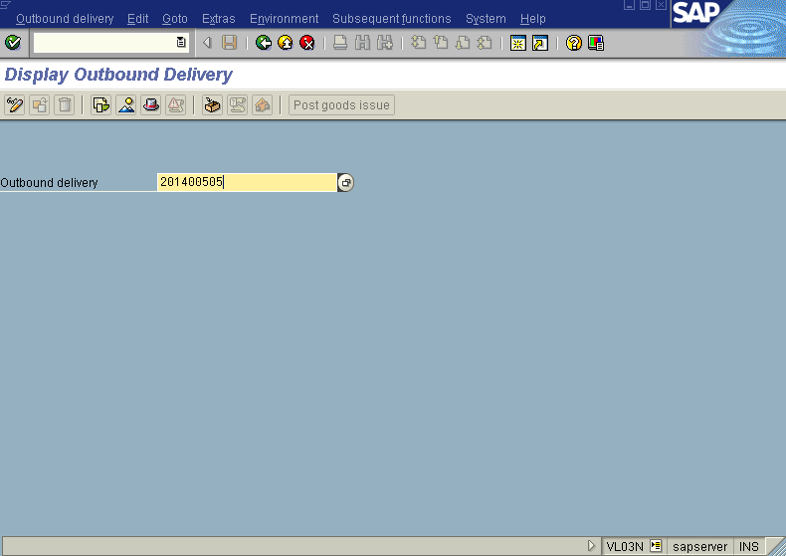

Press enter button we “Delivery CH Mumbai 201400505 display: Overview” screen as under

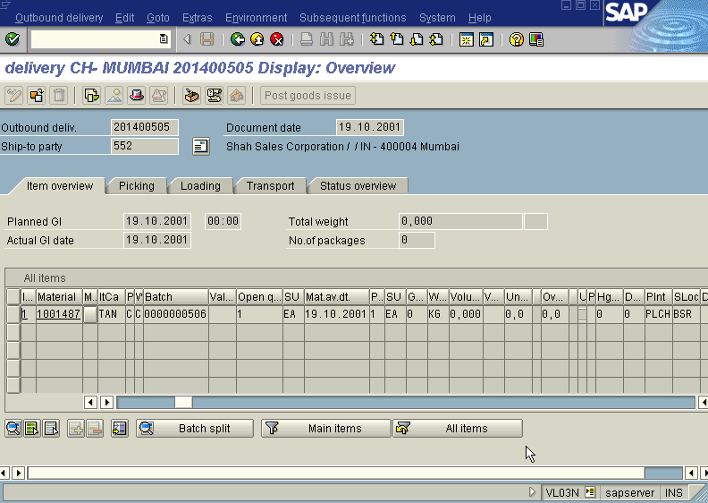

From the above screen we can also have further details by pressing the relevant push buttons viz., Picking,loading,transport,status overview etc.

Important Information which can be seen from Picking

Transaction code LT21. The system displays “Display Transfer Order –Initial Screen” screen as under in which we enter the Transfer Oder number-(1562) we get this number from “Delivery CH Mumbai 201400505 display: Overview “screen and pressing icon Document Flow (F7), warehouse number-(CWH), is defaulted.
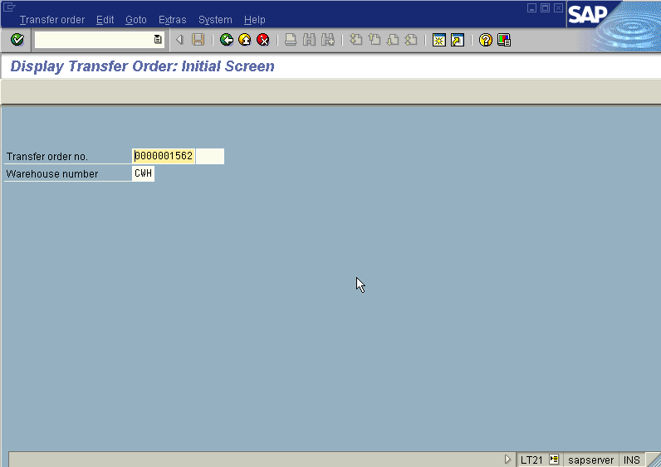

Press Enter button we get “Display Transfer order- Item List” as under

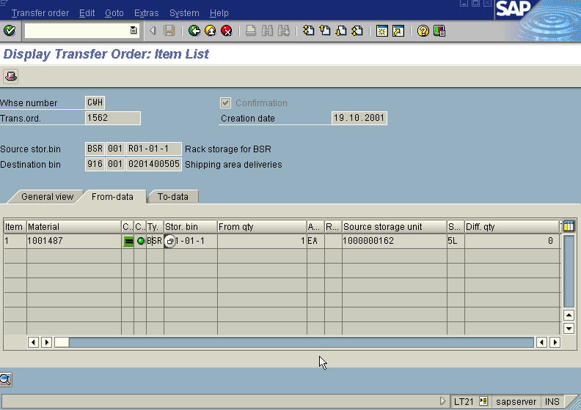

Note: Displays From to Storage bins for the order.

Important Information which can be seen from Billing

Transaction code VF03

The system displays the screen as under in which we enter the billing document number (eg:201500365 in this case)

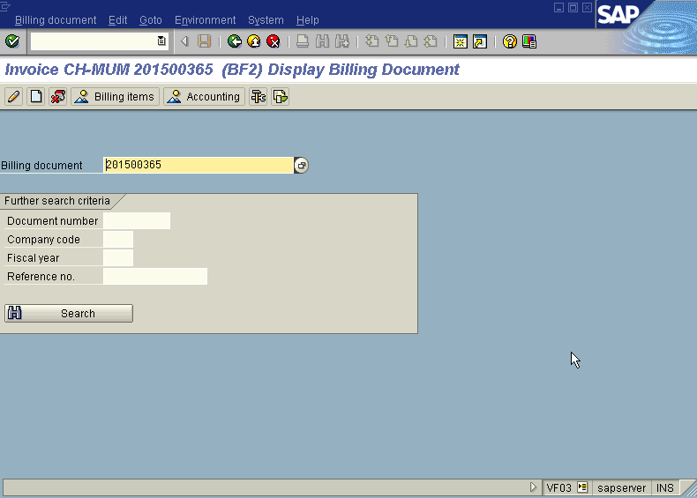

In the above screen press push button accounting

The system displays the “List of Documents in Accounting “screen as under

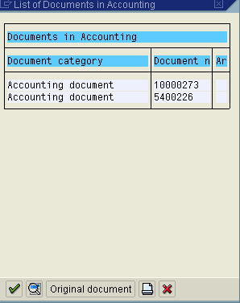

In the above screen if click the Details Icon- (F2) the system displays Document Overview screen as under

